Tab 1

### Contract Processing Steps *(Implementation/Success to fill)*

Contracts for HELIX ALTERNATIVE TECHNOLOGIES INC will look like the following. Please follow the steps to process correctly. Some contracts include:

* Flat Payment
* Initial Payment and Remaining Payment

Steps to process

*You will have to create Different Revenue Schedules for Each type of charge*

##### **Follow Steps below for Flat Payment (Screenshot example below) Flat Payment**

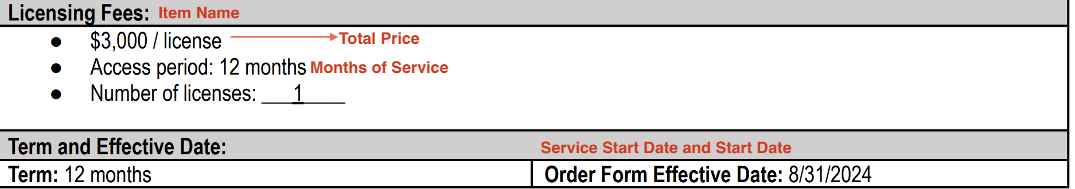

**Service Start Date:** Listed with Order Form Effective Date

**Months of Service:** Listed in Term/Access Period

**Item Name:** Listed in header  
**Item Description:   
Integration Item:** [**TIFIN Netsuite Integration Items**](https://docs.google.com/spreadsheets/d/1fAQ1rHf_buFcowql7ONgAj6gY01wd3u6nwM4ZAUxqhY/edit?gid=515133391#gid=515133391) **find integration item here  
Billing type:** Flat

**Total Price:** Listed with license

**Quantity:** 1 **Start Date:** Same as service start date

**Periods:** Default to 12

**Frequency:** Yearly

**Net Terms:** Default 30

###### Follow the steps below to process contracts that mention an initial payment for a period and remaining timing

###### 

**Revenue Schedule #1- Initial Period**

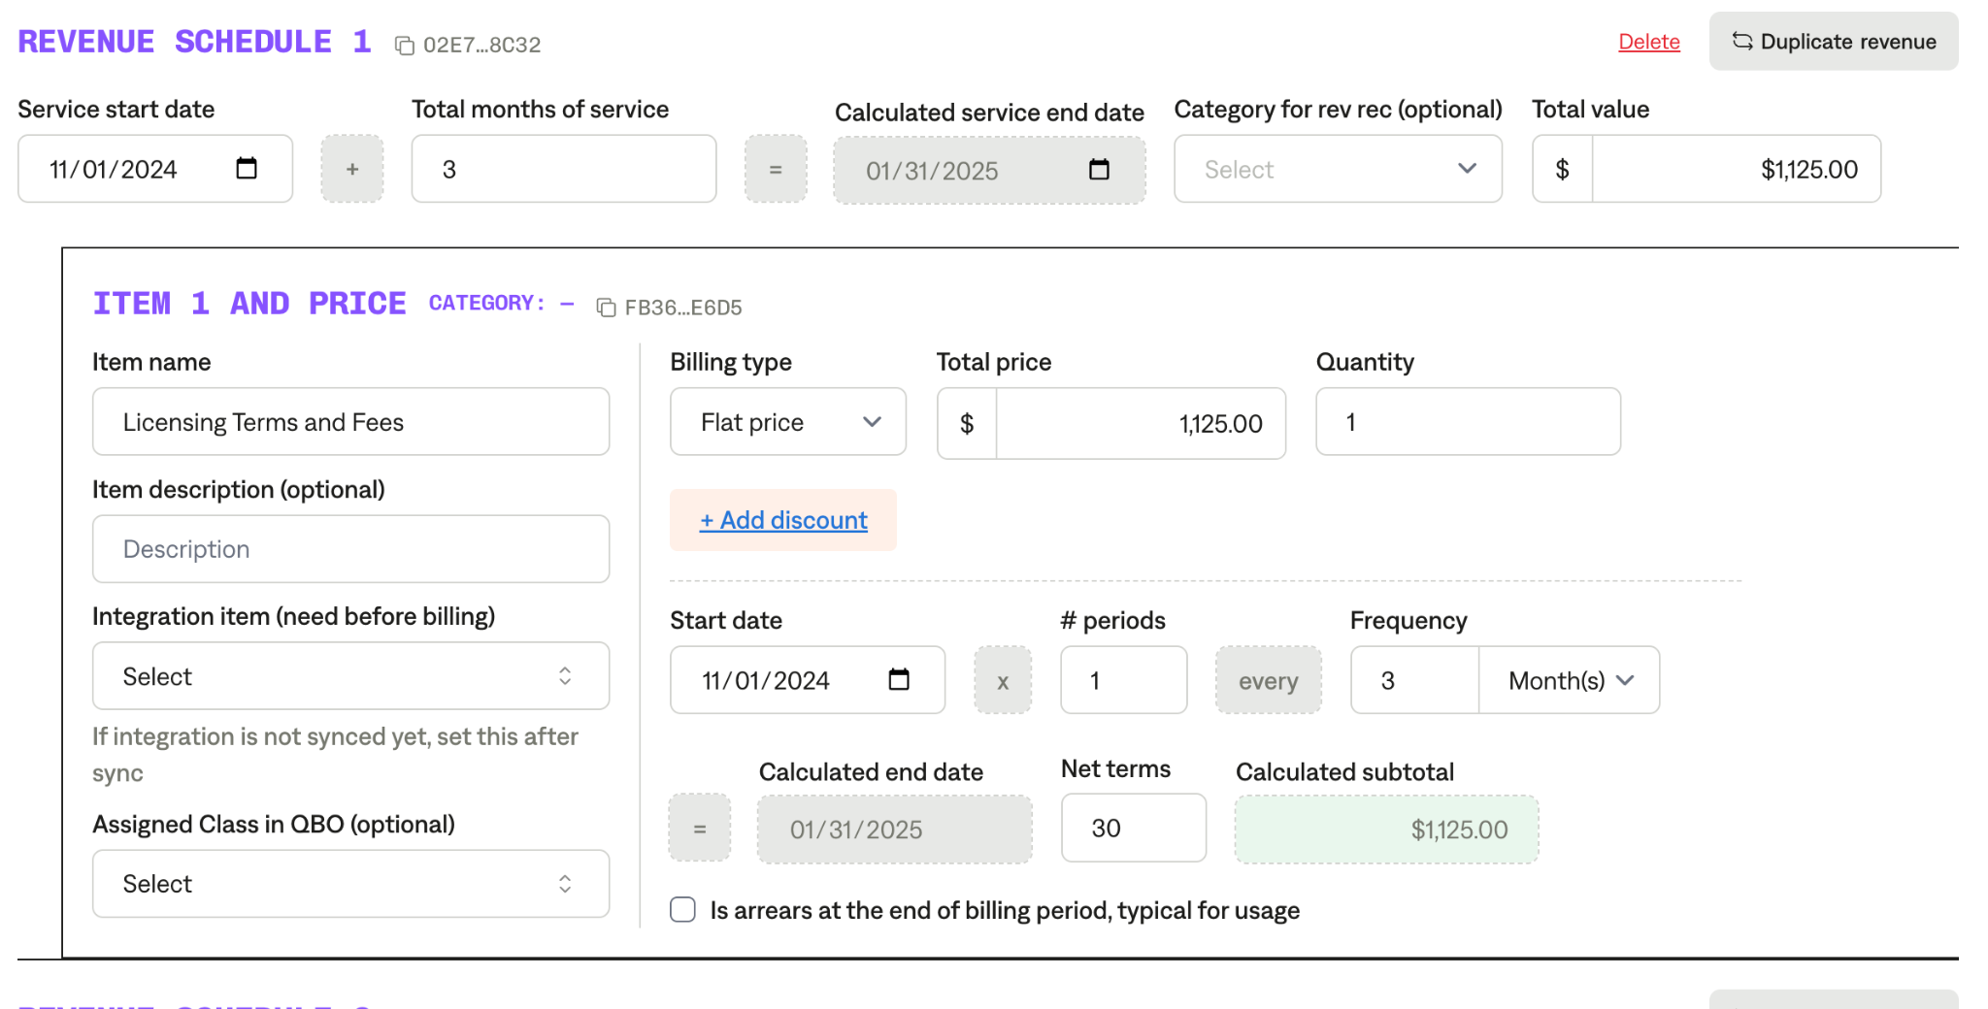

**Service Start Date:** Will be the order form effective date

**Months of Service:** Listed after the price, it will say initial #-month period

**Item Name:** Listed on the screenshot above  
**Item Description:** Blank **Integration Item:  
Billing type:** Flat

**Total Price:** Price stated in contract for initial month period  **Start Date:** Same as the order form

**Periods:** 1

**Frequency:** Monthly length of trial

**Net Terms:** Default 30

**Revenue Schedule #2- Remaining months**

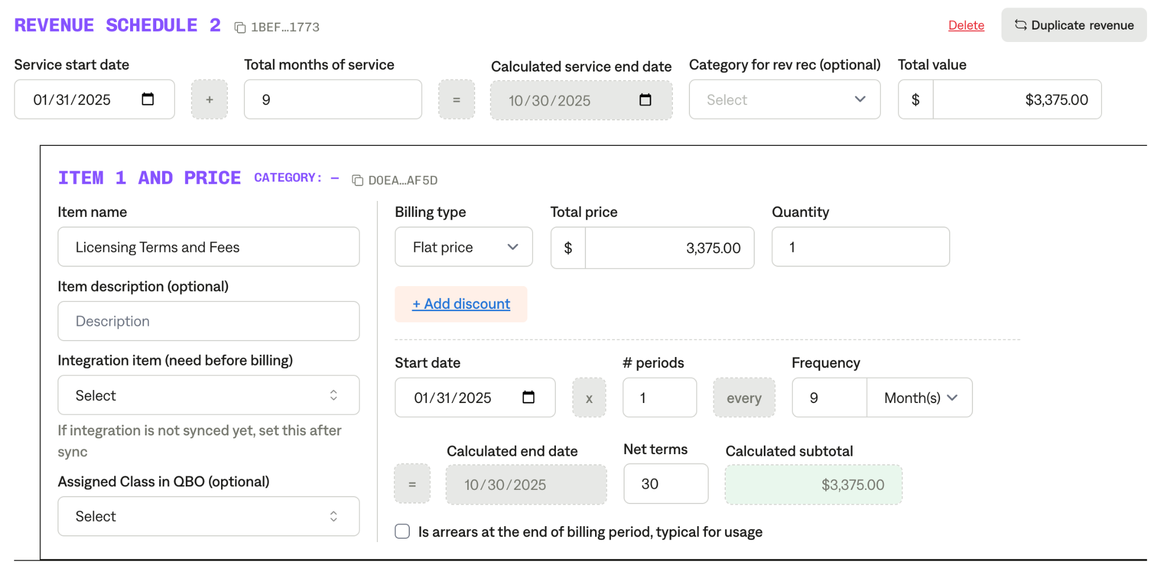

**Service Start Date:** Have it start after the initial trial period is complete.

**Months of Service:** Remaining months after trial period

**Item Name:** Listed on the screenshot above  
**Item Description:** Blank **Integration Item:  
Billing type:** Flat

**Total Price:** License Price - the initial period

**Start Date:** Have it start after the trial period is over

**Periods:** 1

**Frequency:** Monthly length of contract after trial (example: if the trial was 3 months, then you would put 9 months since it is a 12 month contract)

**Net Terms:** Default 30

###### Follow Steps below for the Per Active Employee Per Month Pricing REV SCHEDULE #3 ([example in Garage](https://garage.tabsplatform.com/prod/contracts/8e2c02ef-8b81-4cd2-a919-99745447ada1/terms/key)) (Contract ID: 8e2c02ef-8b81-4cd2-a919-99745447ada1)

**Periods:** default to 12 if monthly

**Frequency:** Yearly unless otherwise specified

**Net Terms:** Default 30

1. Anything to ignore in contracts?
   1. Anything that shows “*waived”*
2. Specifics processing things the merchant has requested that may differ by contract (e.g. always back-date invoice date to final day of the month)
3. Default Service Term
   1. Default 3 Years
4. Default Net Payment Terms
   1. Default 30
5. Default Billing Frequency
   1. If None Listed, Ops Default is Monthly
6. How do we handle taxes as a line item?
   1. If None Listed, Ops Default is every tax line item becomes a BT

### Events Processing (if necessary) *(Implementation/Success to fill)*

* Any important information on events billing

Integration Items Processing (if necessary)  
*(Implementation/Success to fill)*

* What are the instructions for assigning integration items?
* Example: All Statsig integrations items should be labeled as “Sales”
* Example: All “Pinata” integration items should be labeled as “Software Subscription Bundle” unless otherwise noted by Merchant